Safety and Welfare
Your safety and welfare are very important, and we have a special responsibility to safeguard and promote the welfare of all our learners.
This means we should:
- notice if you are being treated badly
- listen to you if you want to talk to us about a problem
- take advice from other professionals if you need extra help.
Young people are nearly always safe at home, at college and in the community, but sometimes things can happen to make you worried, upset or afraid. When young people are hurt in some way by an adult or an older young person this might be what is called child abuse.

If we think a learner has been harmed or is at risk of being harmed, we have a set of rules we follow to help to protect you. These rules are called safeguarding procedures and a copy of our safeguarding policy is available on the college website.

Although your safety is the responsibility of adults there are ways you can help yourself to keep safe too, so we have given you some tips to think about and a list of people you can talk to if you are worried, upset or afraid is included on the back page of this booklet.

Remember, you don’t need anybody’s permission to talk about your worries and you have the right to talk to anyone that you wish.

What do we do to keep you safe?
Eat That Frog does lots of things to help you to stay safe. Here are just some of them:
- We have a safeguarding policy. This explains how children or young people might be harmed, the signs to look for and what staff should do.

- We have other policies that provide information for staff and learners about things like anti-bullying and internet and e-safety.

- All staff go through a check to assess their suitability to work with young people.

- All staff are trained to recognise the signs of abuse and neglect and know what to do if they are concerned about a learner’s welfare.

- We encourage learners to tell us when something is wrong.

- We respect all learners as individuals - and we don’t tolerate discrimination.

- We give learners information to help them keep safe.
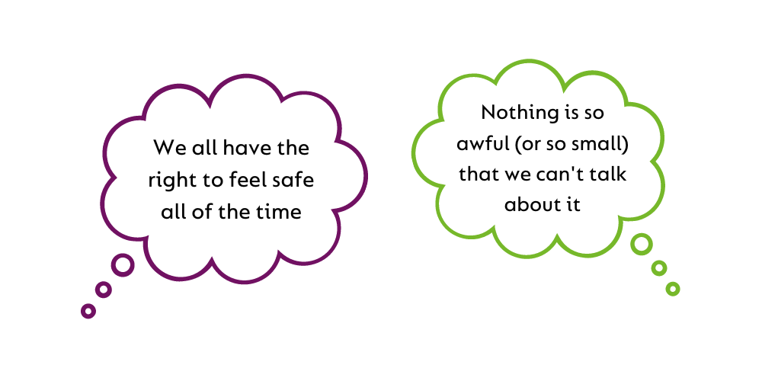

- We do risk assessments to test whether any activity is going to be safe for learners.

- We have a health and safety policy that covers such things as fire regulations, first-aid, food safety and in ensuring the premises are safe for everyone.

- We work in partnership with parents and carers to keep you safe and provide them with information too.

- If necessary, we talk to other people such as social workers and police officers if we think a learner has been harmed or might be harmed by an adult.

Top Tips for keeping yourself safe!
Adults often take action to keep themselves safe and young people must also take action to keep themselves safe. Here are some ideas:
- Try to look confident, even if you don’t feel it - people are less likely to pick on you.

- Try to go places with friends; if you do go out alone always tell someone where you are going and what time you expect to be back.

- Talk to a trusted adult (someone in your family or someone at college) if anyone says or does anything that worries or frightens you.

- Carry a mobile phone and put emergency numbers (a parent or carer, a trusted adult or the police) on speed dial so you can make a call to them quickly.

- If you are taking a bus or train, make sure you have enough money for the return journey. Don’t ever accept money from someone you’ve never met before.

- Don’t accept a lift from someone you’ve never met, call someone to pick you up.

- Remember that alcohol and drugs can harm your health and can also encourage you to take unnecessary risks.

Mobile phones and computers are part of everyday life but used incorrectly they can be a threat to your safety. So:
- Don’t put up with abusive texts, photos or videos. Show them to an adult and make sure the person who sent them knows you are taking action.

- Don’t lend your mobile phone to anyone unless it’s an emergency.

- Don’t give your full name, address or phone number to people on the internet.

- Don’t let anyone online trick you into doing something against your wishes or something you know you shouldn’t do.

- Remember that any emails or photos you upload to the internet can’t be destroyed so THINK before you post something you might later regret.

- You can report internet abuse easily on this great website: www.thinkuknow.co.uk
Share your concerns:
If you are ever concerned about your safety or wellbeing or about the safety of another learner, you should talk to someone such as your parent or carer and/or a member of staff at Eat That Frog such as your Tutor or Centre Manager.
Talking about a problem helps and if the problem cannot be resolved by the member of staff you have talked to, they will find other people to help.
Our staff have received special training in protecting children from abuse and neglect and they make sure the safeguarding procedures are followed.
You can always talk to a member of our Safeguarding team:
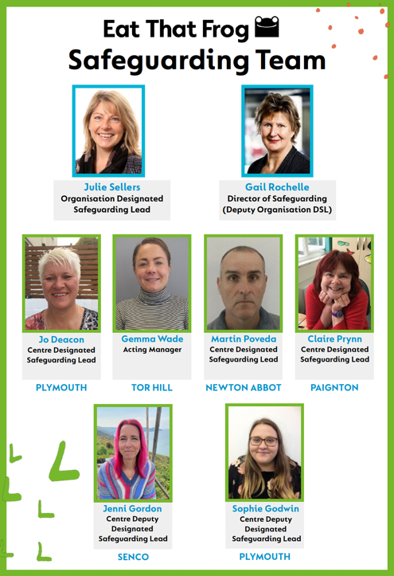

- Julie Sellers (SENCo)
- Gail Rochelle
- Jo Deacon
- Gemma Wade
- Martin Poveda
- Claire Prynn
- Jenni Gordon
- Sophie Goodwin

Other useful contacts:
If you don’t feel you can talk to someone at Eat That Frog, there are lots of other people who can help!

Police: call 101 (or 999 in an emergency)
Childline: 0800 1111 - help for children and young people
Kooth: www.kooth.com - online counselling for young people
The Samaritans: 08457 909090
Talk to Frank: 0800 776600 – for information about drug-related issues in a no-nonsense way, you can call FRANK free, 24/7.

